**Installation of ROS2 Jazzy Jalisco in Linux Ubuntu 24.04 (Noble)**

**Contents**

1. [Resources](https://docs.ros.org/en/jazzy/Installation/Ubuntu-Install-Debs.html#resources)
2. [System setup](https://docs.ros.org/en/jazzy/Installation/Ubuntu-Install-Debs.html#system-setup)

* [Set locale](https://docs.ros.org/en/jazzy/Installation/Ubuntu-Install-Debs.html#set-locale)
* [Enable required repositories](https://docs.ros.org/en/jazzy/Installation/Ubuntu-Install-Debs.html#enable-required-repositories)

1. [Install development tools](https://docs.ros.org/en/jazzy/Installation/Ubuntu-Install-Debs.html#install-development-tools-optional)
2. [Install ROS 2](https://docs.ros.org/en/jazzy/Installation/Ubuntu-Install-Debs.html#install-ros-2)
3. [Setup environment](https://docs.ros.org/en/jazzy/Installation/Ubuntu-Install-Debs.html#setup-environment)
4. **Resources**

Status Page:

* ROS 2 Jazzy (Ubuntu Noble 24.04): [amd64](http://repo.ros2.org/status_page/ros_jazzy_default.html), [arm64](http://repo.ros2.org/status_page/ros_jazzy_unv8.html)
* [Jenkins Instance](http://build.ros2.org/)
* [Repositories](http://repo.ros2.org/)

1. **System setup (Follow the commands one by one)**
2. **Set locale**

Locale # Check for UTF-8

sudo apt update && sudo apt install locales

sudo locale-gen en_US en_US.UTF-8

sudo update-locale LC_ALL=en_US.UTF-8 LANG=en_US.UTF-8

export LANG=en_US.UTF-8

locale # verify settings

1. [**Enable required repositories**](https://docs.ros.org/en/jazzy/Installation/Ubuntu-Install-Debs.html#id4)

* First ensure that the [Ubuntu Universe repository](https://help.ubuntu.com/community/Repositories/Ubuntu) is enabled.

sudo apt install software-properties-common

sudo add-apt-repository universe

* Now add the ROS 2 GPG key with apt.

sudo apt update && sudo apt install curl -y

sudo curl -sSL [https://raw.githubusercontent.com/ros/rosdistro/master/ros.key -o /usr/share/keyrings/ros-archive-keyring.gpg](https://raw.githubusercontent.com/ros/rosdistro/master/ros.key%20-o%20/usr/share/keyrings/ros-archive-keyring.gpg)

* Then add the repository to your sources list.

echo "deb [arch=$(dpkg --print-architecture) signed-by=/usr/share/keyrings/ros-archive-keyring.gpg] http://packages.ros.org/ros2/ubuntu $(. /etc/os-release && echo $UBUNTU_CODENAME) main" | sudo tee /etc/apt/sources.list.d/ros2.list > /dev/null

1. **Install development tools**

sudo apt update && sudo apt install ros-dev tools

1. **Install ROS 2**

* Update & Upgrade your apt repository caches after setting up the repositories.

sudo apt update

sudo apt upgrade

sudo apt install ros-jazzy-desktop

sudo apt install ros-jazzy-ros-base

1. **Setup Environment**

source /opt/ros/jazzy/setup.bash

**Result (Upto setting up of environment)**

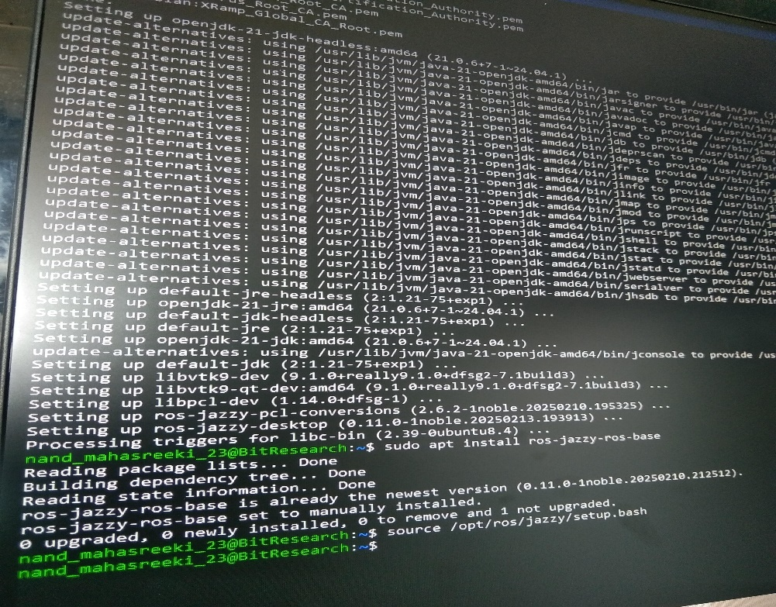

**Installation and execution of turtlesim package**

* Turtlesim is a lightweight simulator for learning ROS 2.
* It illustrates what ROS 2 does at the most basic level to give you an idea of what you will do with a real robot or a robot simulation later on.

1. **Install Turtlesim**

start by sourcing your setup files in a new terminal

sudo apt update

sudo apt install ros-jazzy-turtlesim

Check whether the packages are installed

ros2 pkg executables turtlesim

1. **Start Turtlesim**

ros2 run turtlesim turtlesim_node

1. **Use Turtlesim**

Open a new terminal and source ROS 2 again.

ros2 run turtlesim turtle_teleop_key

Use the arrow keys on your keyboard to control the turtle.

1. **Results**

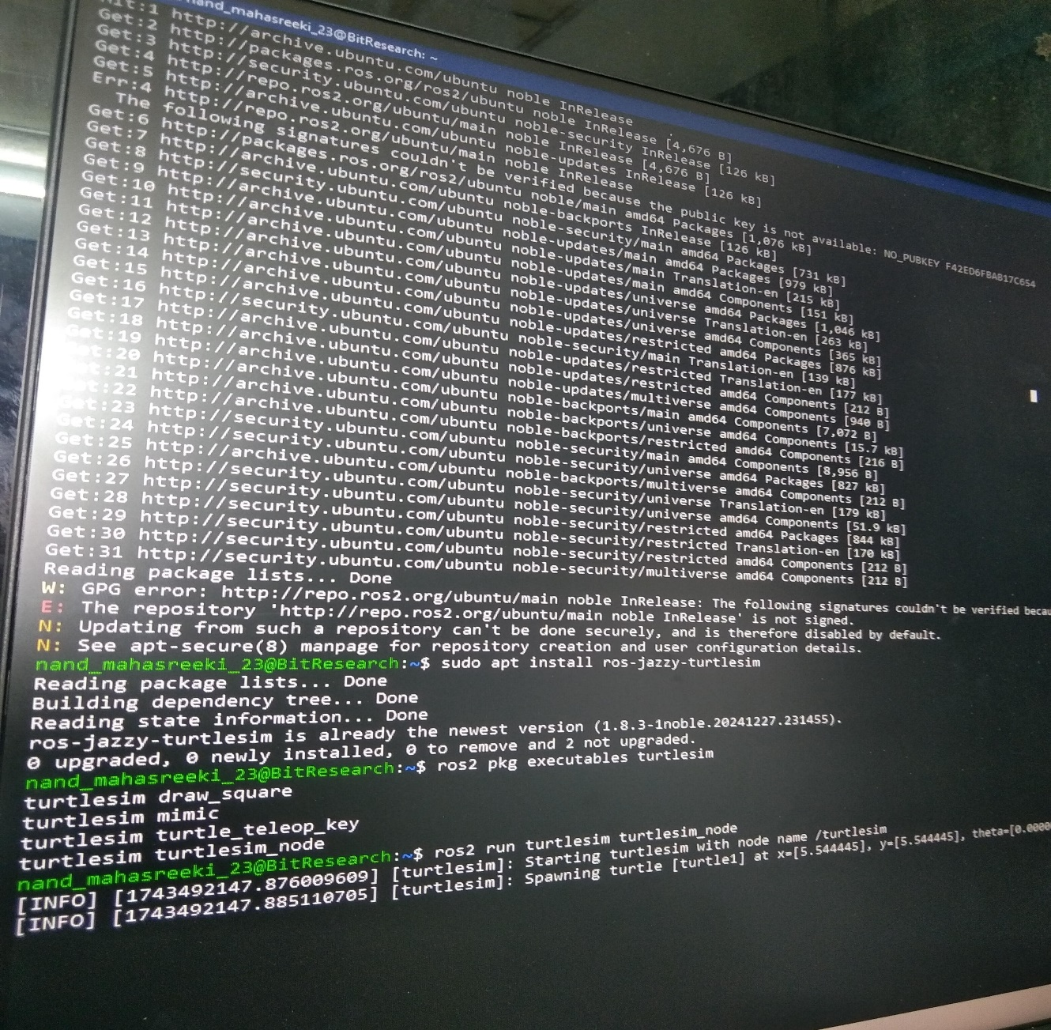

(The display after the copmpletion of 2nd step)

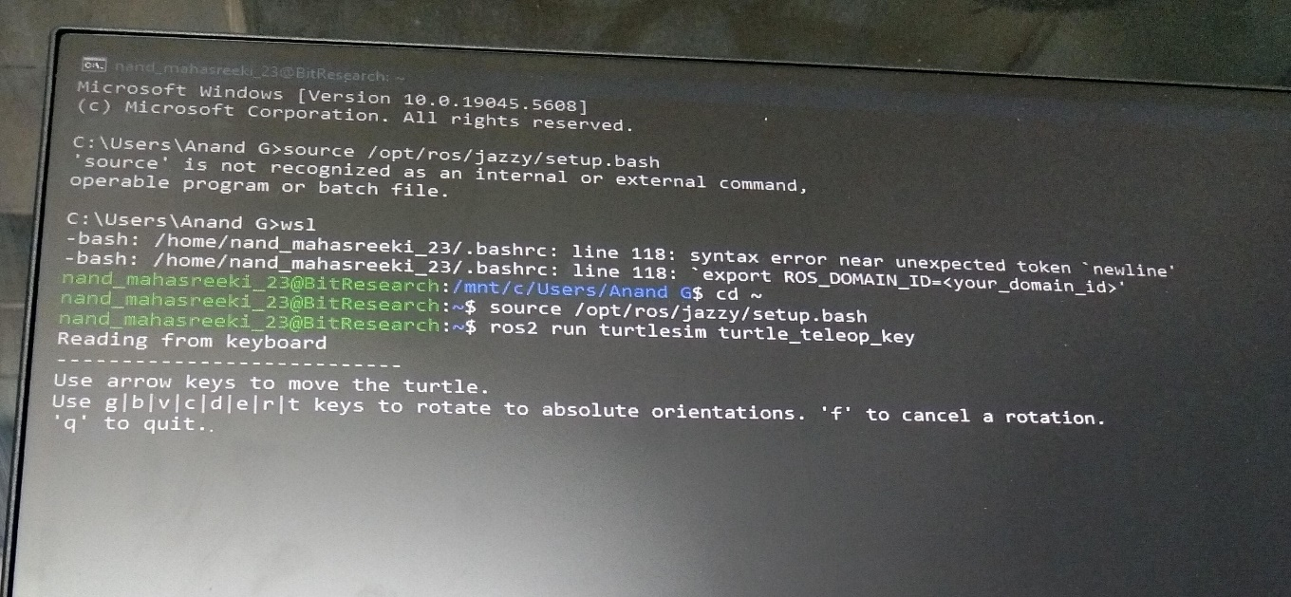

(Display after the completion of 3rd step)

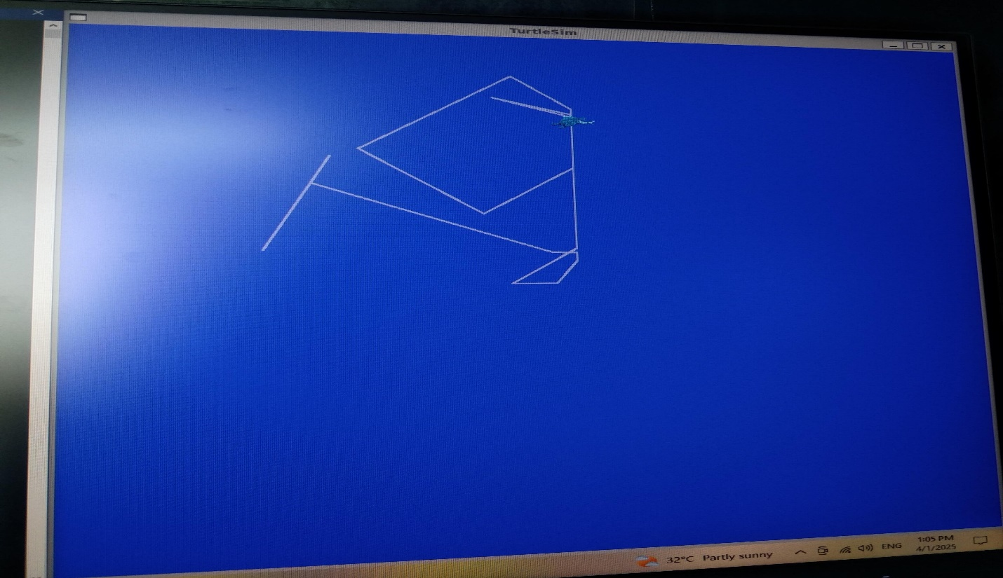

(Display of moved turtle in random directions)